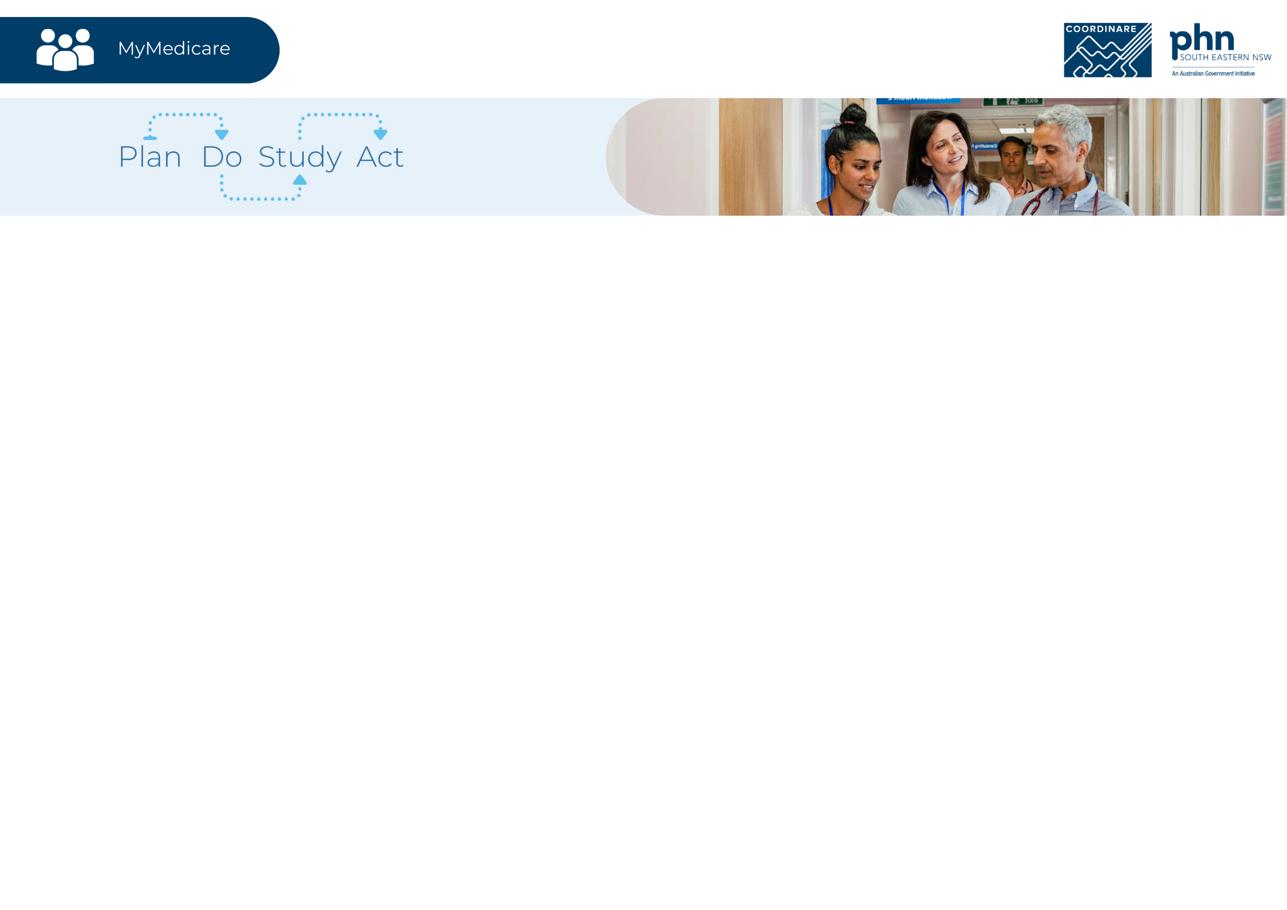

|  |  |  |  |
| --- | --- | --- | --- |
| Quality Improvement Activity | | | |
| Practice name: |  | Start date: | End date: |
| Quality improvement activity: |  |  |  |
| **Goal**  *What are we traying to accomplish?* |  | | |
| **Change ideas**  *What change can we make that will result in an improvement?* |  | | |
| **Benchmark**  *What is our current data saying?* |  | | |
| **Measures**  *What data will we use to track our improvement?* |  | | |

|  |  |  |  |
| --- | --- | --- | --- |
| Quality Improvement Team | | | |
| Name |  | Name |  |
| Role / responsibilities |  | Role / responsibilities |  |
| Name |  | Name |  |
| Role / responsibilities |  | Role / responsibilities |  |

|  |  |  |  |
| --- | --- | --- | --- |
| Plan | Do | Study | Act |
|  | * *Did we do it?* * *What happened along the way?* * *Unexpected problems?* * *Implement the plan and record observations.* | * *What did/didn’t work well?* * *Review/reflect on results.* * *Lessons learnt.* * *Analyse and learn from the results.* | * *Next steps?* * *Review or extend activity?* * *If the activity was successful, consider how to adopt the change. If it was not successful, refine the plan based on your learnings and commence the cycle again.* |