**EXPRESSION OF INTEREST**

**EOI Reference No: EOI-2526-02**

**Aboriginal Facilitator**

**Women’s Business, Women’s Way - A Health Screening Program**

**Due: 5:00pm Wednesday 3 September**

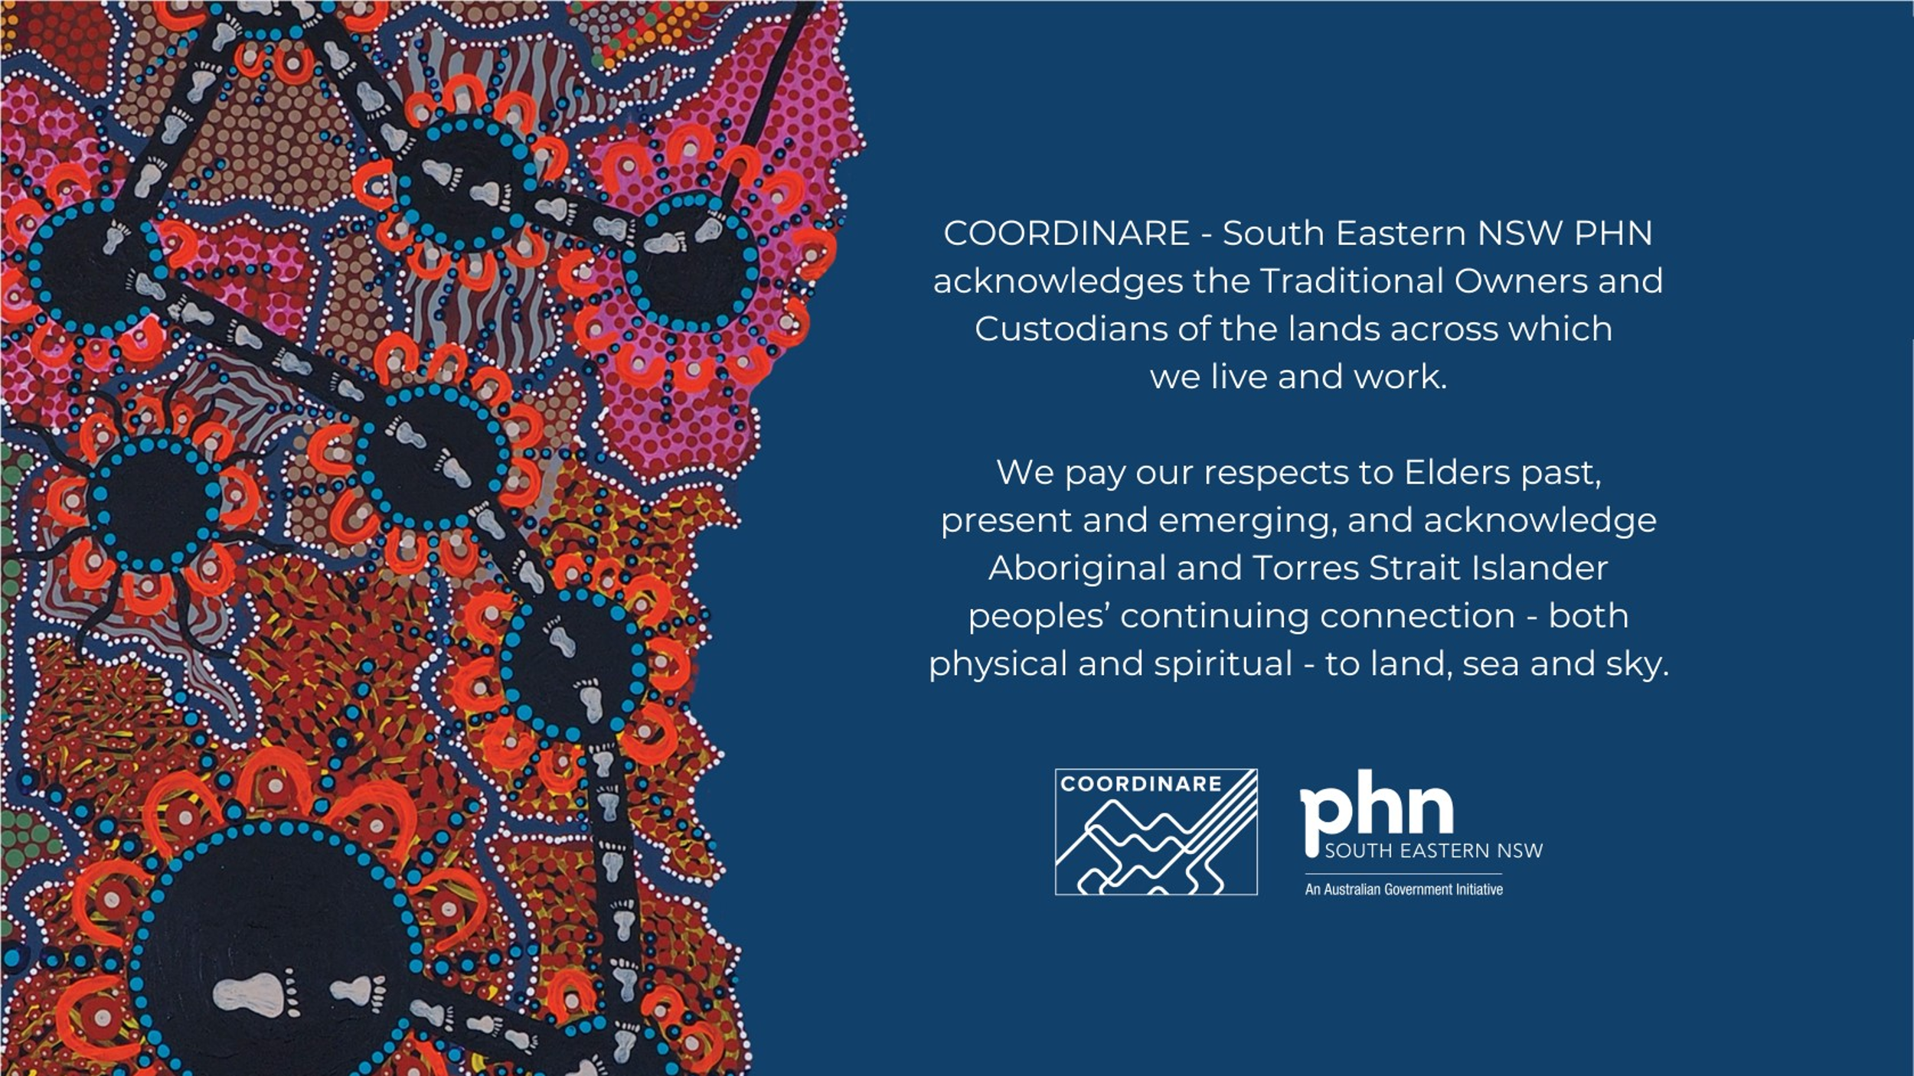

Table of Contents

1. Introduction 3

2. Who can apply? 3

3. Background & Funding purpose 3

4. Scope and specifications 4

5. Timeline 4

6. How to apply 4

7. How to contact us 5

8. Evaluation of submission 5

9. Contract arrangements 6

10. Project Governance 6

11. Application form 6

12. Conditions of this Expression of Interest 7

## Introduction

COORDINARE, as the South Eastern NSW Primary Health Network, is dedicated to fostering healthier communities. We focus our efforts on those who face the biggest inequities. To do this, we collaborate with the community, general practices and other stakeholders to design solutions that make it easier for people to get the health care they need. **More information about COORDINARE – SENSW PHN can be found on our** [**website**](http://www.coordinare.org.au/)**.**

COORDINARE is inviting Aboriginal female group facilitators and/or cultural educators to apply for funding and be part of a women’s business health project.

As part of this program, your role will be to lead three yarning circles with Aboriginal women across the Illawarra Shoalhaven to explore culturally safe approaches to cervical screening.

There is funding of **up to $10,000 ex GST** to facilitate 3 yarning circles between October and December 2025.

## Who can apply?

This process is what COORDINARE calls an ‘Open Expression of Interest’ (EOI).

What this means is that any Aboriginal female facilitators or cultural educators who live on or have cultural and community connections to Country in the Greater Illawarra or Shoalhaven Region can apply.

Only one proposal will be selected to be part of the project. You are welcome to submit a proposal that includes more than one facilitator/cultural educator.

You do not need to have an ABN or be registered for GST to apply.

## Background & Funding purpose

Across the country, less than half of Aboriginal and Torres Strait Islander women are having their cervical screening done, compared to about two-thirds of non-Indigenous women. Because fewer Aboriginal women are getting screened, more are getting sick with cervical cancer. This also means that more Aboriginal women are dying from cervical cancer — almost four times more than non-Indigenous women. Closing this gap is so important to keeping women strong and well and looking after the health of their families and communities.

The Illawarra and Shoalhaven regions have the largest Aboriginal communities in the South Eastern NSW PHN region. This is why these places have been chosen for this program.

As part of this project Aboriginal women will come together to talk about cervical screening. Through yarning and storytelling, the facilitator will guide the way to understand and shape culturally safe approaches.

As an experienced facilitator / cultural educator, you will help facilitate a safe space to discuss barriers and supports to screening, including the role of self-collection and HPV vaccination.

Insights will shape a local health promotion campaign and inform commissioned artwork, ensuring the program reflects cultural knowledge, community voices, and the needs of Aboriginal women.

The yarning circles will be supported by COORDINAREs Aboriginal Health Consultants, as well as Aboriginal female clinicians.

A female Aboriginal artist will participate in the yarning circles, listening to the stories and wisdom shared, and will create an artwork that reflects these voices. This artwork will become the heart of a campaign to raise awareness and start conversations about cervical screening in community.

The artwork will feature in campaign advertising and be printed on merchandise to support community engagement. These items will be used during promotional activities and shared with women at community events and health screening days to help spread the message in a meaningful and respectful way.

## Scope and specifications

* Facilitate 3 yarning circles as advised by COORDINARE
* Use storytelling and culture of yarning to draw out community perspectives on health, barriers, and enablers
* Provide cultural input on how health messages should be framed and shared with community.
* Must be comfortable hearing and facilitating discussions about Women’s Business, (specifically cervical screening)

Activities out of scope

* The facilitator is not expected to provide cervical screening education or clinical advice to participants. Health promotion and screening discussions will be facilitated by trained health workers and project staff.

## Timeline

An indicative timeline is outlined below. COORDINARE reserves the right to modify these timeframes. Any changes to this EOI will be notified via email.

|  |  |
| --- | --- |
| **Activity** | **Date** |
| EOI released | 7 August 2025 |
| Online yarn for people to ask questions about this project  Registration for this session via link here: [Online yarn for Women’s Business, Women’s Way: A Women’s Health Screening Program – Cultural Facilitator](https://events.teams.microsoft.com/event/e961f544-d2d5-48a3-ad17-d756acf4147e@a4173a8f-e1ac-4499-a647-6d8ea5351f29)  This session will be recorded and published on COORDINARE website. | 1:00 pm to 1:45 pm  18 August 2025 |
| Closing date and time for applications | 5:00pm Wednesday 3 September 2025 |
| Evaluation of EOI | September 2025 |
| Clarification / negotiation with shortlisted providers | September 2025 |
| Funding awarded | September 2025 |
| Contracts commence | September 2025 |
| Yarning circles | Between October & December 2025 |

Please note that any questions, answers, and points of clarification may be shared with publicly (your questions will be deidentified).

## How to apply

**We’d love to hear from you in the way that feels most comfortable and right for you.**

You have 3 options for sharing your response:

1. **You can fill out the written EOI Response Form (Appendix 1)** and include anything else that helps explain your ideas or your artwork. You can email the completed **Application form (Appendix 1)** to [commissioning@coordinare.org.au](mailto:commissioning@coordinare.org.au).

**File formats accepted:** word, excel, pdf and jpg files are all acceptable formats. If the documents are large please specify the relevant page number(s)/section(s) to your response.

1. You can complete an **[Application form](https://coordinareau.sharepoint.com/sites/comm/20252026/PCD%20-%20Improving%20cervical%20screening%20in%20Aboriginal%20women/Guidelines/Cultural%20Facilitator/FYi%20only)** on our website. Your progress will not be saved if you close the window or refresh the page. We recommend completing the application in one session. **OR**
2. **You can send us a short video**, where you talk us through your responses and show us your art or creative ideas. You may use any of the following platform to upload your video:

* Online storage platforms such as OneDrive/ Google Drive/ Dropbox.
* YouTube (unlisted or private link recommended for security).

Ensure the link is publicly accessible or set with appropriate permissions so we can view it.

* For **Google Drive/OneDrive/Dropbox**, make sure the sharing settings allow anyone with the link to view.
* For YouTube, set the video to Unlisted so it’s not publicly searchable but still accessible via the link.

You can submit the video link via Application Form or send the video link to email address: [commissioning@coordinare.org.au](mailto:commissioning@coordinare.org.au). COORDINARE will not share your video link with any third parties, other than the project team and evaluation panel members of this project.

Please take your time reading through the questions and make sure your application matches the scope and specifications in section 4 in this document. Please also make sure you respond to all the assessment criteria in section 8 of this document.

All responses will be looked at fairly by a small independent panel of Aboriginal women who are here to support this important, community-led work.

Please submit your response by 5:00pm (AEST) on Wednesday 3 September 2025. To be fair to everyone who applies, **submissions submitted after cut-off date and time will not be considered**.

## How to contact us

For any questions regarding this process please email Commissioning Business Team at [commissioning@coordinare.org.au](mailto:commissioning@coordinare.org.au).

## Evaluation of submission

Submissions will be assessed via a competitive process. This means each submission will be looked at fairly and checked against the same set of criteria to see which one best fits the project. Each submission will be assessed against the Assessment criteria below:

* Can you please give an overview of your previous experience as a facilitator or cultural educator?
* Can you share a time when you supported community members to talk about something deeply personal or difficult. What helped make that space feel safe and respectful?
* How would you support women to feel comfortable sharing their stories and experiences during the yarning circles?
* How do you see your role in helping bring community voices into a health project like this?

The assessment will be done by an independent evaluation panel made up of Aboriginal women.

COORDINARE may request additional information from respondents. COORDINARE may also work with shortlisted respondents to clarify submissions, prior to awarding a contract.

## Contract arrangements

Successful applicants will be required to enter into a grant agreement with COORDINARE. The term of the contract awarded will be from the date of execution until 31 December 2025.

Staged payments will be made to the facilitator/organisation in accordance with the following project milestones as specified (negotiable):

* On signing of the contract - 40% of total contract value.
* Completion of third yarning circle: 60% of total contract value.

## Project Governance

COORDINARE is committed to ensuring all participants feel safe, supported and respected during this project.

This project will be Aboriginal-led internally, guided by COORDINARE’s Aboriginal Health Consultants.

An Aboriginal-led working group will be established to guide the design and delivery of the project. This group will include representatives from:

* Community
* Aboriginal Community Controlled Health Organisations (ACCHOs)
* Grand Pacific Health (GPH)
* Local Health District (LHD)
* COORDINARE

Community yarning circles will be central to the engagement process. These will be:

* Facilitated by a female Aboriginal cultural facilitator,
* Supported by Aboriginal Health Workers, Practitioners, or Aboriginal Nurses to ensure cultural and clinical safety
* Supported by a female Aboriginal health professional who can provide emotional and social wellbeing support to community on the day
* Held in community settings to ensure comfort and easy access.

If there is anything you need from COORDINARE to help, make this a safe and meaningful experience for you and the community you can make a note on your application form.

## Application form

Click here for the application form